2015 Weekly Budget to Actual Collection (December 13th )
 | Regular Collection | Maintenance Fund | Pay Down the Debt
Weekly Budget for 2015 | 3,923.00 | 115.00 | 1,000.00
Contribution Dec. 13th | 4,387.90 | 1,502.00 | 1,723.00
 | 464.90 | 1,414.00 | 723.00

Mass Intentions
Saturday, Dec. 20th (5:00 p.m.) + Alex Chartrand
Sunday, December 13th (9:00 a.m.) + Lorne Kelndorfer

Choir Practices for Christmas Eve Masses
Midnight Mass – Sunday, December 20th @ 3:00 p.m.
9:30 p.m. Christmas Eve Choir – Tuesday, December 22nd @ 7:00 p.m.

Our Lady of the Hill K of C
Selling Sobeys and No Frills Grocery Cards at the back of the church after all masses.
Keep Christ in Christmas” car magnets in both French and English are also available at a cost of $5.00.

Our Lady of the H Ill K of C Council #13064 wishes to thank all who supported our Pie Sale last Weekend.

We have Bibles (including children's) and catechisms for sale in the library.

Blank Schedules for Christmas and New Year’s Eve Masses are at the back of the church. Please fill in your name for the masses that you will be attending.

PLEASE pick up your 2016 Donation Envelopes at the back of the church.
If you have not used envelopes previously and would like a set please contact the parish office.

BAPTISM -For children 4 and older, St. Vital Parish is offering a mini Baptismal preparation course. One evening for one hour. (Children under 4 years can attend if accompanied with an adult)
The next courses that is offered at St. Vital Parish: is January 12th at 5pm
Also... parents must attend a baptism preparation course.

Reflection for the Year of Mercy - December 20th - Fourth Sunday of Advent In proclaiming the Jubilee Year of Mercy, Pope Francis proclaimed his desire that this Holy Year be “steeped in mercy,” as we disciples “go out to every man and woman,” bringing the “balm of mercy” to “believers and those far away, as a sign that the Kingdom of God is already present in our midst!” (Misericordiae Vultus, 5). In her visitation of Elizabeth, Mary beautifully presents just such an image. Despite the perils of her pregnancy, not to mention her preoccupations as a young unwed mother, Mary instantly, unselfishly, “goes out” of herself, hastening far and over dangerous terrain, to “bring the balm of God’s tender mercy” in assistance rendered to her older relative. Since baptism and the Eucharist have made us, in a way, bearers of the living Christ within as Mary was, such selfless “going out” of ourselves to be of loving service to others in mercy should especially mark our Christmas season this Jubilee Year.

CHRISTMAS & NEW YEARS MASS TIMES

Christmas Eve
Thursday, Dec. 24th
5:00 p.m. Children’s Christmas Pageant
5:30pm Mass
7:30 p.m.
9:30 p.m. (incense)
12:00 am Midnight (incense)

Christmas Day
Friday, Dec. 25th
10:30am
The Feast of Mary, Mother of God
(A Holy Day of Obligation in Canada)
New Year’s Eve
5:00pm
New Year’s Day
10:30 a.m.
Please bring a bell to mass with you on Christmas Eve/Christmas Day to ring during the Gloria

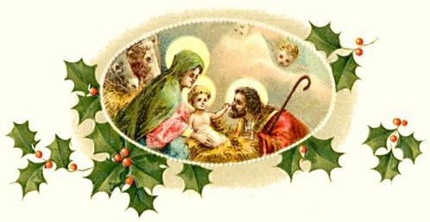

The Parish Office will close December 23rd and will reopen on January 4th, 2016. Voice mails and e-mails will still be answered during this time.

.

