2015 Weekly Budget to Actual Collection (December 6th )
 | Regular Collection | Maintenance Fund | Pay Down the Debt
Weekly Budget for 2015 | 3,923.00 | 115.00 | 1,000.00
Contribution Dec. 6th | 3,929.00 | 203.00 | 453.00
 | 6.00 | 88.00 | -547.00

Mass Intentions
Saturday, Dec. 12th (5:00 p.m.) + Felipe Cruz
Sunday, December 13th (9:00 a.m.) + Pat Foesier
Tuesday, Dec. 15th (9:00 a.m.) + Merenciano Manalang
Thursday, Dec. 17th (9:00 a.m.) + Gwen Sattler

Our Lady of the Hill K of C
Selling Sobeys and No Frills Grocery Cards at the back of the church after all masses.
Keep Christ in Christmas” car magnets in both French and English are also available at a cost of $5.00.

Knights of Columbus Council #13064 Pie Sale after all masses next weekend (Dec. 12 & 13).

We have Bibles (including children's) and catechisms for sale in the library.

Blank Schedules for Christmas and New Year’s Eve Masses are at the back of the church. Please fill in your name for the masses that you will be attending.

PLEASE pick up your 2016 Donation Envelopes at the back of the church.
If you have not used envelopes previously and would like a set please contact the parish office.

Father’s Holy Hour –Every Wednesday evening 9:00 p.m. – 10 p.m.

God of the meek and the simple, strip away the complexity we make for ourselves. Free us from the things we think we should do, and turn our minds and hearts to what you ask of us. Help us to let go of worry and anxiety, judgment and resentment, anger and self-righteousness. May we faithfully embrace trust, gratitude, simplicity and contentedness.
Amen.

"CWL is sponsoring a donation drive for the Marion Centre (men's shelter) during the advent season (Nov 29, Dec 6 & 13). We are looking for used men's clothing particularly: jeans, hoodies, sweat pants, shoes, winter boots, jackets, gloves (not mittens), thermal underwear and toques. We are also accepting new underwear (not XL), socks, disposable razors, travel deodorant and insoles for shoes.
Questions can be directed to Belinda 780-236-0057."

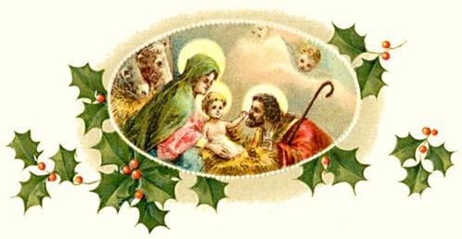
CHRISTMAS – NEW YEAR’S MASS SCHEDULE
December 24th 5:00 p.m. Children’s Nativity Play
Masses 5:30 p.m., 7:30 p.m., 9:30 p.m. & Midnight (bilingual)
December 25th 10:30 a.m.
December 31st 5:00 p.m.
January 1st 10:30 a.m.

.December 13 -Third Sunday of Advent
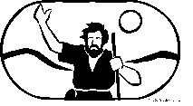
Pope Francis chose to inaugurate the Jubilee Year of Mercy last Tuesday because December 8 marks the 50th anniversary of the closing of the Second Vatican Council. That council, Pope Francis reminds us, inaugurated a new phase in the Church’s history. The Spirit called the Church to tear down the walls that for far too long had made it a fortress, and to proclaim the Gospel in a new, more accessible way. Pope Francis quotes St. John XXIII in declaring the Church’s preference for “the medicine of mercy,” and Blessed Paul VI in proposing the Good Samaritan as our model for discipleship (Misericordiae Vultus, 4). Pope Francis adds that God’s mercy is “the beating heart of the Gospel,” and that mercy “must penetrate the heart and mind” of every disciple (MV, 12). Three times today’s Gospel asks, “What should I do?” Pope Francis would say: Imitate Jesus, who came not wielding the fiery judgment that John the Baptist had threatened, but instead imparting healing, compassion, forgiveness — mercy!

Online Faith Formation
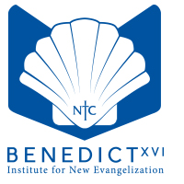
Registration is now open for the next cycle of classes in the the Certificate in Catholic Studies (CCS), offered by the Benedict XVI Institute for New Evangelization through Newman Theological College. The following courses will begin onMonday, January 4: Catholicism; Scripture; Prayer; Church History II; The Practice of Youth Ministry: Social Justice; Liturgical Practices; Acts and New Testament Writings; Rite of Christian Initiation of Adults; Reconciliation. All are offered online, so you can study from the comfort of home and work around your personal schedule. Each course runs five weeks and costs just $70. Take an individual course for interest, or work toward one or all of the six specialized Certificates in Catholic Studies. This program is open to adults and youth of all backgrounds and education levels.Register online at www.newman.edu/CCS. For more information, contact Michelle Maxwell at 780-392-2455 or michelle.maxwell@newman.edu.

Ministry of Pastoral Care: Certificate Program for Volunteers
The Archdiocese is pleased to offer training for volunteer pastoral care ministers on Friday evening and Saturday, January 29-30, at the Pastoral and Administration Offices.
With the support of their parish pastor and under the direction of the parish pastoral team, the role of the volunteer minister of pastoral care is to provide spiritual support to the sick, the shut-in or the incarcerated in either an institution or private home. This comprehensive 10-hour program offers participants a better understanding of pastoral care given to hospital patients, continuing care and assisted living residents, community shut-ins and congregation members.
Registration cost is $75. A pastor’s reference letter and current Police Information Check (PIC) including the Vulnerable Sector Check are required. For more details or to download the registration forms, visitwww.caedm.ca/workshops or contact Natalie at 780-469-1010 ext. 2130 ornrose@caedm.ca.

.

