September 25, 2022
Twenty-sixth Sunday In Ordinary Time

Ministry Sign-up Schedule for the month of October weekends is at the back of the church. Please sign up for a mass you will be attending.

Weekend Mass Times
Saturday 5:00 p.m. (English) Sunday 9:00 a.m. (bilingual) 11:00 a.m. (English)

WEEKDAY MASSES
Tuesday, October 4th @ 9:00 a.m.
Wednesday, October 5th – NO MORNING MASS (funeral for Edith Collin @ 11:00 a.m.)
Thursday, October 6th – Mass @ Academy St. Andre School
Fridy, October 7th – NO MORING MASS

NO ADORATION until October 14th

Check out our website www.saintvitalparish.com and check it regularly for updates.

Mass Intentions
Saturday, October 1st – SI Madeleine Berube
Sunday, October 2nd (9:00 a.m.)†Andy Desrochers (11:00 a.m.) SI Sharon Brown
Tuesday, October 4th – SI Kate Vukovic
Saturday, October 8th – SI Kevin Barrett
Sunday, October 9th – †Mariane Valle

† = Repose of the Soul SI = Special Intention

Our Lady of the Hill Knights of Columbus will be selling Sobey and No Frills gift cards after all masses on the weekend.

Scent Free Makes Sense
We would like the parish to be sensitive to folks with allergies and refrain from wearing perfume and aftershave at Mass. Thank you in advance for your consideration.

It is now time to register for Sacramental Preparation for First Communion and First Reconciliation
First Reconciliation & First Communion
Parents’ Information Meeting
October 11th or 13th, 2022 at 6:00 p.m.
Please bring a photocopy of the child’s baptism certificate.
Registration and information for First Reconciliation and Frist Communion is available on our website under the Sacraments heading

Catholic Education Prayers of the Faithful for October
• For Catholic Education: That our Blessed Mother may wrap all children in her mantle of love and bring them ever closer to her Son, we pray to the Lord.
• For Catholic Education: That gratitude be our way of living and being in this world, we give thanks to the Lord.
• For Catholic Education: that the love of the Rosary and devotion to the Virgin Mary may thrive within our Catholic schools, we pray to the Lord
• For Catholic Education: That our Catholic schools may be blessed with courage and energy to continue to live out their invaluable role in our society, we pray to the Lord.
• For Catholic Education: That our Catholic schools may be inspired by the example of the many great saints who have gone before them and who intercede for them, we pray to the Lord.

Reverse Collection
A reverse collection for the Leduc Food bank will be taken the weekend of Oct. 8th & 9th.
Slips of paper with requested items will be handed to parishioners on October 1st & 2nd.
Thank you for helping those in need.

Vinnies Treasure Shoppe SSVP Edmonton Central Council invites parishioners to browse our new store for vintage furniture, housewares and collectibles, 10306 – 112 Street, Edmonton. We have a lovely collection of unique items at great prices, and friendly volunteers on hand to assist. Each purchase helps the Society of Saint Vincent de Paul help those in need in our community. Open 11am-4pm Tuesday, Thursday & Saturday. https://www.ssvpedmonton.ca/vinnies-treasure-shoppe

SNOWFLAKE BAZAAR 2022
Saturday, November 5th, 2022

Paroisse St. Vital Parish’s annual SNOWLAKE BAZAAR is in the planning! Plans are underway for the return of our fun-filled event.
You can appreciate that much work and planning needs to be done beforehand so please mark your calendars today and plan to support us in some way. Wonderful plans for a children’s areas is in the works so small homemade items suitable to be bought by young people for parents, siblings, etc. would be welcomed. And we expect the bake sale to be bigger than ever with goodies of all sorts and perhaps some fresh canning as well.
Volunteers will once again be needed to prepare our traditional tourtières as the ‘crew’ have elected to sell our meat pies on a few weekends in November as we did for the last two years during the pandemic, with great success we might add!
We anticipate holding our first formation meeting in early September so please keep informed via the bulletin or the parish website at https://www.saintvitalparish.com/
Do you have something unique and exciting you’d like to prepare for the Bazaar and could use some help, give us a call (780-929-8320) and a work bee or two can be arranged. In the event some work bee days can be fulfilled this summer and you have some time to dedicate to small projects please leave your name and phone number with our Bazaar Chairperson Carmen at 780-929-8320 or by email at carmen.grayson@telus.net.
Any questions or concerns can be directed to the Bazaar Chairman.

Adoremus & Credo
Adoremus (“Let us Adore”) is held at St. Joseph Basilica from 7:00 PM – 8:30 PM on the first Saturday of every month beginning on Oct 1 (Nov 5, Dec 3, Jan 7, Feb 4, Mar 4, Apr 1, May 6, Jun 3). Join other young adults for an evening of Eucharistic Adoration, music, reconciliation, and prayer.
Credo (“I Believe”) will be from 7:00 PM – 9:00 PM at Newman Theological College held monthly on Thursdays beginning Oct 13 (Nov 17, Dec 15, Jan 19, Feb 16, Mar 16, Apr 13, May 11). Join other young adults and dive into the mysteries of our faith! This cultural apologetics series will focus on a different topic each month. A social and light refreshments will follow. All are welcome!

Star of the North Retreat Centre, www.starofthenorth.ca, 780-459-5511
Ways of the Heart: Reimagining Compassion Women’s Retreat – What does a healthy practicing of compassion—and self-compassion—look like? Join presenters Sandra Prather and Glenda Sartore for a powerful weekend of teaching, reflection and celebration. October 14-16, 2002. Registration Deadline is October 7th (only 3 in-person spaces remaining). Cost: Online $165 / Commuter $255 / Live-In $395 www.starofthenorth.ca/compassion
Outcasts Who Belong: Jesus & the Unnamed Women in the Gospels Join this three-week series online or in-person with well-known educator Sister Teresita Kambeitz. Choose afternoons or evenings to attend in November as we reflect on Jesus encounters with 10 outsider women who belong as insiders in the new world he came to establish. November 8, 15, & 23. Early registration prices end October 15th. Cost: $90 (online or in-person) www.starofthenorth.ca/outcasts
The What, Why, Where & How of Being a Synodal Church is an informal evening with teacher Sandy Prather exploring questions around what it means to ’walk together in the Spirit’ as a synodal church. Thursday, November 10 at 7:00 pm. Early registration prices end October 15th. Cost: $20 (online or in-person) www.starofthenorth.ca/synodal
In the Moment: Self-Guided Retreats are recorded retreats intended for people who may want to retreat at home or on the road, have limited mobility, and/or simply seek time alone with God in the midst of a busy schedule. Each video is less than 45 minutes, and may be paused to allow space for deeper reflection and prayer. Available in Spanish, French & English. Quarterly subscription (3 videos): $75 / Yearly subscription (9 videos): $200 For more information visit: www.starofthenorth.ca/moment

Is your child between the ages of 6 and 15 and not yet baptized or baptized in a different Christian faith? We have a program just for them- RCIC (RCIA adapted for children)

If you are interested in having your older child(ren) baptized, and would like more information, please contact the parish at 780-929-8541.

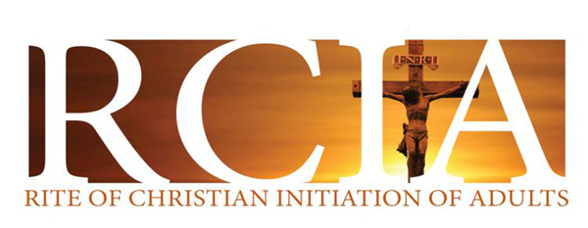
- Are You Interested in Becoming a Catholic?
- Maybe you are baptized but have not been confirmed or have not received your first communion?
- Have you always wanted to learn more about your faith and become part of a community?
The Rite of Christian Initiation of Adults (RCIA) provides an opportunity for adults thinking of joining the Church to learn more about the Catholic faith. Adult Catholics who have not been confirmed or who have not celebrated their first communion are also invited to be part of this process. Through RCIA you journey through an engaging, challenging, enriching experience that is designed to help you come closer to God, and the Church.

Interested persons are asked to contact the parish at 780-929-8541, to schedule an appointment before starting the process.

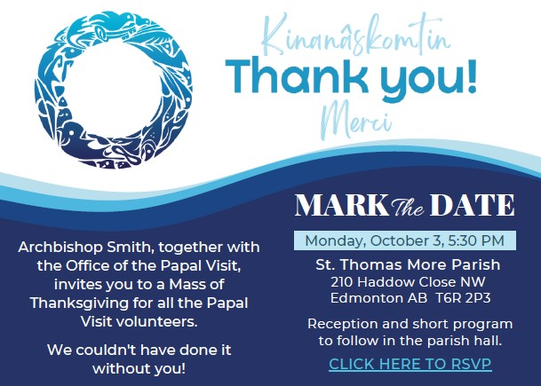

Knights of Columbus 50/50 Charities Appeal Raffle

The Alberta Knights of Columbus are holding their annual Charities Appeal fundraiser once again as a 50/50 online raffle. The draw will be held on December 9, 2022 and the prize is half of the jackpot, with a minimum amount of $25,000. We invite you to purchase raffle tickets by using the QR code on the two posters at the back of the church or by accessing them at www.koc5050.com.

Except for the prize and direct costs to run the raffle, all proceeds from the raffle will go to charities all over the province. Please help us to make this raffle the most successful one yet.

When purchasing tickets online, please identify Beaumont Council #13064 Our Lady of the Hill Council as the Council you are supporting. Our council will receive a share of the net proceeds that is directly proportional to the amount we have raised.
