June 19, 2022
[Sidebar Title]

THE MOST Holy Body and Blood of fChrist (Corpus Christi)

Sign-up schedule for proclaimers for the month of July weekends is at the back of the church. Please sign up for a mass you will be attending.

Weekday masses
Tuesday-Friday (June 21st – June 24^{th)} @ 9:00 a.m.
Weekend Mass Times
Saturday 5:00 p.m. (English) Sunday 9:00 a.m. (bilingual) 11:00 a.m. (English)
ADORATION –FRIDAY, June 24th

Check out our website www.saintvitalparish.com and check it regularly as there will be no weekly bulletins during the months of July and August!

PARISH PICNIC
Saint Vital Parish is having a picnic on Sunday, June 26th after the 11:00 mass. The parish will supply hamburgers and hot dogs. We would ask that each family provide a potluck dish of either an appetizer, salad, or dessert. Also, bring a lawn chair. To assist us in our planning please let us know if you will be attending by signing up at the back of the church with your name and the number attending. You can also reply with your numbers via e-mail at st.vitalchurch@shaw.ca We would like to have these numbers by JUNE 19th. The Knights of Columbus have graciously agreed to cook the meat. We will need some extra help with set up before the 11:00 mass and help with the clean up. If you can help out please sign your name on the sheet at the back of the church. We look forward to seeing many of you there!
POPE FRANCIS VISIT TO CANADA
There will be two pew collections within the Archdiocese of Edmonton to help with these costs. The first will be June 18-19, prior to National Indigenous Peoples Day on June 21. The second collection will be July 23-24. Pope Francis arrives in Canada on July 24.
Donations may be made:
- Online through Canada Helps at https://bit.ly/2022PapalVisit
- By cheque to the Archdiocese of Edmonton, duly marked “Papal Visit.”
- Special Marked Envelopes at the back of the church
We thank you in advance for supporting this historic visit of Pope Francis to Canada
Mass Intentions
Saturday, June 18th, -† Leger & Annette Demers
Sunday, June 19th – (9:00 a.m.) – † Guy Rodrigue
Tuesday, June 21st – †Lorna Weisengerber
Wednesday, June, 22nd – †Lorna Thomas
Sunday, June 26th (11:00 a.m.) † Ladislas Rodrigue
† = Repose of the Soul SI = Special Intention
Please pray for the people of Ukraine as they suffer an unprovoked and unjustified attack by Russian military forces.

Prayer for Ukraine
O God of love, we pray for the people of Ukraine,
the frail and the elderly,
the women and children who are left alone,
grieving families with loved ones who have fallen,
and the multitudes who have lost everything.
O God of peace, how we long that violence will cease,
that the machines of war,
will be transformed into implements of peace.
Be with the leaders of this world,
that their decisions will be keenly oriented
towards a just and lasting peace.
O God of compassion, open our hearts,
to care for the refugees who may come to our shores
and the needy stranger in our midst.
For Christ’s sake. Amen.
Scent Free Makes Sense
We would like the parish to be sensitive to folks with allergies and refrain from wearing perfume and aftershave at Mass. Thank you in advance for your consideration.

K of C Food Bank Drive
K of C Food Drive
The Knights of Columbus will hold its monthly food drive in support of the Leduc Food Bank the weekend of June 25-26. Please drop your donation in the bin in the Church vestibule. Thanks to all the Parishioners who have been supporting this effort over the months. The needy of Leduc County thank you as well.

Our Lady of the Hill Knights of Columbus will be selling Sobey and No Frills gift cards after all masses on the weekend.

Stewardship Corner
Solemnity of the Most Holy Body and Blood of Christ June 18/19, 2022
From the rich Eucharistic themes to be drawn from today’s second reading, one stewardship theme stands out: The Eucharist is Christ’s gift to us. Good stewards are grateful for this gift and realize that no matter their station in life, they are welcome to come to the table and receive the body and blood of Christ. If Jesus could break bread with His betrayer, Judas, His denier, Peter, and the other ten who deserted Him, then He will welcome us. Do we truly appreciate what a tremendous gift it is to approach the Lord’s table? Do we realize that the Holy Spirit means to transform us by the gift of Christ’s body and blood?

ROSARY FOR THE FAMILY
In preparation for the 10th World Meeting of Families (WMF) that will take place in Rome and in dioceses across the world June 22 - 26, 2022, the CCCB Standing Committee for Family and Life is hosting a live and nationwide Rosary for the Family via Zoom Webinar. The virtual event will take place on Sunday, June 19, 2022 at 1:00 pm and will be facilitated by several families from across the country.
For more information and for the link to register: caedm.ca/rosary-for-the-family/

SKARO SHRINE ANNUAL PILGRIMAGE
On the evening of August 14, 2022, the 104th Annual Skaro Pilgrimage will be held at the Grotto in Skaro.
This year’s pilgrimage begins with confessions from 6:30 - 7:30 pm followed by the praying of the rosary. Vespers will then be sung in Polish, the mother tongue of the settlers who built the stone grotto in 1919, followed by Mass at the grotto (in English). Following Mass, the candlelight procession of the Blessed Sacrament and Benediction will conclude the evening.
On Monday, August 15 at 10:00 am there will be a special Mass with the Sacrament of the Sick. The Blessed Sacrament Procession with lit candles will follow the Blessing of the religious articles.
Pilgrims are asked to bring their own chair and food if needed. Lunch for purchase will be available at the Vigil on August 14.
Skaro Shrine is 80 km northeast of Edmonton, at the intersection of Highway 45 and Secondary 831.

National Indigenous Peoples Day
Tuesday, June 21 - 26th Anniversary
Canadians will be celebrating National Indigenous Peoples Day. This is a day that celebrates and recognizes First Nations, Métis, and Inuit cultures. It is observed on the 21 of June to recognize the summer solstice, the day of maximum daylight, and its importance to Indigenous Peoples.
RETROUVAILLE: A LIFELINE FOR MARRIED COUPLES
Retrouvaille is a marriage program that helps couples restore their marriage and rebuild a loving relationship. Spaces available beginning the weekend of August 12 - 14. For more information, 587.598.4357, or info@helpourmarriage.ca or visit our website at www.helpourmarriage.ca

The Foundation needs golfers, join us today,
The Annual Newman Golf Classic will celebrate its 30th Anniversary this summer and we want you to be part of it.
We invite you to combine your love of the game with your love of the Lord, and join us on Monday, July 11 at the spectacular Blackhawk Golf Club for this highly anticipated event.
For more information and to review registration form or sponsorship matrix to find the sponsorship opportunity that is right for you, please visit www.caedm.ca/golf or contact Anna Jaremko at golf@caedm.ca 780-952-6437.
CATHOLIC YOUTH CAMPS
Camp Ministry in the Catholic Archdiocese of Edmonton has a rich history. Many young people have built lasting friendships and experienced the truth, beauty, and goodness of the Catholic faith at one of our camps. We’re so excited to announce that in 2022, a team of youth & camp ministry veterans (including Mike Landry, Jeannette Manser, and Peter van Kampen) will be hosting Catholic Youth Camps at the beautiful Camp Oselia on Wabamun Lake. We’re preparing three weeks jam-packed with epic games, sports, swimming, laughter, great food, learning about the faith, and prayer... all done while spending time in the beauty of God's creation. Join us for:
- Savio Week (youth entering grades 10-12 in September) Monday, July 25 – Friday, July 29, 2022

- Encounter Week (youth entering grades 4-6 in September) Monday, August 1 – Friday, August 5, 2022Our Lady of Victory Week (youth entering grades 7-9 in September) Monday, August 22 – Friday, August 26, 2022

- Camp Oselia is located on the North shore of Wabamun Lake - you simply head west out of Edmonton Highway 16, turn south on Range Road 53, and you're there. The cost for a week of camp this year is $295 per camper per week. Grade 10-12 students will also have an opportunity to volunteer as a junior counselor for one of the other weeks in the summer. For more information on our camps program, please visit https://www.caedm.ca/camps.

Volunteering for Pope Francis’ pastoral visit to Canada can be of enormous personal, social and spiritual benefit. If you are 18 or older and willing to share your time and talents, organizers are seeking many volunteers for innumerable tasks during the papal visit, from greeting and directing pilgrims, to providing translation services, aiding guests with special needs and performing a variety of other roles. If you are under 18, you are welcome to apply to volunteer if accompanied by a parent or guardian.
For more information, please visit papalvisit.ca. The site includes an online form for people to register as volunteers.

We are delighted to share the joy of the upcoming pastoral visit by Pope Francis to Canada on July 24-29, 2022. This visit will be one of healing, hope and reconciliation that we hope will be a watershed moment for the Indigenous Peoples of this land and the Church’s relationship with them.
The Vatican has confirmed that the Holy Father will utilize three hubs for the visit to Canada: Edmonton, Quebec City and Iqaluit. It will be a much more modest visit than a usual papal pilgrimage, due to the Holy Father’s age, health, and mobility issues.
Still, there are costs associated with the visit, including lodging and event security, event production costs and site logistics. National organizers estimate the total cost of the visit at $15 million, and are working to secure support from all levels of government as well as the private sector.
There will be two pew collections within the Archdiocese of Edmonton to help with these costs. The first will be June 18-19, prior to National Indigenous Peoples Day on June 21. The second collection will be July 23-24. Pope Francis arrives in Canada on July 24.
PRAYER FOR FATHER’S DAY
“GOD OUR FATHER,
WE GIVE YOU THANKS AND PRAISE FOR FATHERS YOUNG AND OLD.
WE PRAY FOR YOUNG FATHERS, NEWLY EMBRACING THEIR VOCATION;
MAY THEY FIND COURAGE AND PERSEVERANCE
TO BALANCE WORK, FAMILY AND FAITH IN JOY AND SACRIFICE.
WE PRAY FOR OUR OWN FATHERS
AROUND THE WORLD WHOSE CHILDREN ARE LOST OR SUFFERING;
MAY THEY KNOW THAT THE GOD OF COMPASSION
WALKS WITH THEM IN THEIR SORROW.
WE PRAY FOR MEN WHO ARE NOT FATHERS
BUT STILL MENTOR AND GUIDE US WITH FATHERLY LOVE AND ADVICE.
WE REMEMBER FATHERS, GRANDFATHER, AND GREAT GRANDFATHERS
WHO ARE NO LONGER WITH US
BUT WHO LIVE FOREVER IN OUR MEMORY
AND NOURISH US WITH THEIR LOVE.
AMEN”

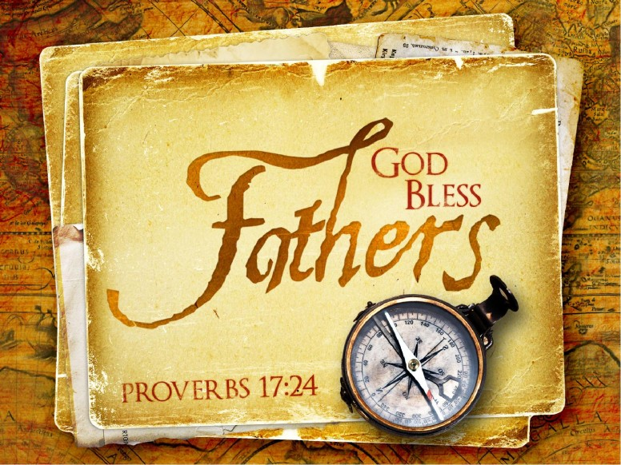

A little child in church for the first time watched as the ushers passed the offering plates.
When they neared the pew where he sat, the youngster piped up so that everyone could hear: "Don't pay for Daddy, I'm under five."

