DECEMBER 19, 2021 Fourth SUNDAY OF ADVENT
[Sidebar Title]

Sign-up schedule for proclaimers for the month of January weekends is at the back of the church. Please sign up for a mass you will be attending.

Weekday masses
Tuesday, Wednesday Thursday (December 21st, 22nd & 23rd) @ 9:00 a.m.
No 9:00 am. weekday masses on December 29th & 30th and January 4th & 5th

Weekend Mass Times
Saturday 5:00 p.m. (English) Sunday 9:00 a.m. (bilingual) 11:00 a.m. (English)
Reconciliation – Saturday 4:15 p.m. – 4:45 p.m.

NO ADORATION on Friday, December 24th

Mass Intentions
Saturday, December 18th – SI Lucille Magnan
Sunday, (11:00 a.m.) December 19th † Maurice Gariepy
Wednesday, December 22nd † Laurent LeBlanc
Thursday, December 23rd † Laurent LeBlanc
Sunday, December 26th - SI Lucille Magnan
† = Repose of the Soul SI = Special Intention

Parish Office closed on December 27th & 28th

Attention Snowbirds Please consider signing up for Pre-Authorized Debits before you head south for the winter. You can register in person at the parish office or fill out the Pre-Authorized Debit Agreement (available in the church) and put it in the collection basket. Thank you for your continued generosity to St. Vital.

Attention Parishioners
On Sept. 15, the Alberta government declared a local state of public health emergency. COVID cases and hospitalizations are increasing, putting extreme pressure on the health system. The Alberta government has mandated new, temporary measures to curb the spread of COVID. Therefore, the following measures are to be implemented as of this date unless stated otherwise. Here is what’s new. New measures have also been highlighted. What’s new?

• Masks are mandatory
• Capacity is limited to one-third fire code occupancy
• Attendance at baptisms is allowed for up to 50 people or 50 per cent of fire code occupancy, whichever is less.
• No social gatherings are permitted in parish halls and facilities.
• Each parish will implement previous protocols to determine attendance (At the present time St. Vital will use first come, first served)
• The dispensation from the obligation to attend Sunday Mass continues for dioceses in the Province of Alberta.

PARISH OFFERING ENVELOPES

2022 donation envelopes are ready to be picked up. Envelope users that had numbers over 200 have been issued new numbers. Please do not use the envelopes until 2002.
If you are interested in receiving a box of collection envelopes for the 2022 year or would like information on Auto Debit for your donations, please call or email the parish office @ 780-929-8541, or St.vitalchurch@shaw.ca.

Our Lady of the Hill Knights of Columbus will be selling Sobey and No Frills gift cards after all masses on the weekend. They are also selling : "Keep Christ in Christmas" car magnets (in French and in English). Cost is $5.00 each.

Stewardship Corner Fourth Sunday of Advent Weekend of December 18/19, 2021
As we draw close to the great Feast of the Nativity, we hear the bold stewardship proclamation twice in today’s second reading from the Letter to the Hebrews: “Behold, I come to do your will, O God!” Who is this Jesus? Who are we that in A STEWARDSHIP MOMENT we should follow Him? Many want Him as a friend, a guide, a king, an advocate. We long to see the face of God. Jesus reveals the nature of God, the servant sent to give us new life in Him. Take time to ponder: Do we have the courage to follow Jesus? To show others the face of God? To say to the Lord: “Behold, I come to do your will?”

Star of the North Retreat Centre, www.starofthenorth.ca, 780-459-5511
- Advent Mission: The 4 Quarters of Advent – Turning Our Humanity to the Presence of the Lord with Fr. Mark Blom, OMI. Saturday, December 18. Cost: In-person - $90; Online - $40 www.starofthenorth.ca/advent
- Aurora Living: Formation Through Word & Creation. Why not make our winter module—Wilderness: From Slavery to Freedom—a part of your Lenten journey? Join a community at the intersection of faith & contemporary issues: creation care, social justice & reconciliation. Opening retreat: January 7-9. www.starofthenorth.ca/wilderness

To the 48 volunteers who made and sold just over 800 tourtières
in the month of November
a BIG thank you
and to our parishioners who supported our fundraising event
we are pleased to say that this year’s efforts brought in
a profit of $8,616.15 to pay Down The Debt.

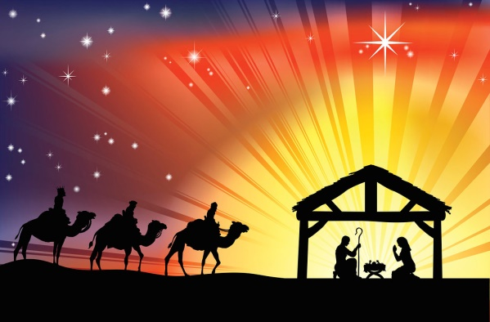
Wishing you and your families the very best for this holiday season.
Stay safe and healthy!

\

LIVING IN THE WORD
To be disciples, to live in accord with our Baptismal identity and dignity, is to allow only His words to guide and direct our lives. Let us take great care to hear only His Word, to turn away from any voice that leads us from Him, and to put into practice that which He tells us. Then we shall know the joy of living as His brothers and sisters.
Archbishop Smith, Pastoral Letter, September 14, 2017

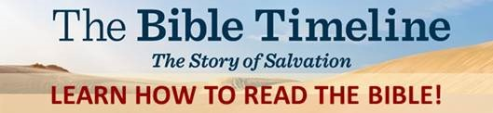
Cost: ~$50 for Study Guide. The course is free.
PLEASE REGISTER NOW to ensure we order enough Study Guides for January.

To register or for more information, contact: Alana at alaperle@telus.net or call the parish office at 780-467-5470
Presented by Our Lady of Perpetual Help Parish, Sherwood Park. EVERYONE IS WELCOME! You do not have to be a member of OLPH to participate.
Mondays, 6:30-8:30 p.m. Starts January 3 OR Saturdays, 10 a.m.-12 p.m. Starts January 8
Live online via Zoom
Reading the Bible should bring us closer to Christ, but understanding it is often difficult.
The good news is that you can understand the Bible, and The Bible Timeline makes it easy. In this 23-part study, presenter Jeff Cavins takes you on a journey through the Old and New Testaments, giving you the keys to understand the amazing story woven throughout Scripture

C-YEG: A new young adults ministry
The Catholic Young Adults of Edmonton (C-YEG for short) will promote special young adult events as well as events from other organizations for those who are thirsting for a faith community. Young adults are invited to the C-YEG Mass on the third Sunday each month at St. Charles Parish at 4 p.m.
C-YEG was born out of a great desire to have a citywide space for young adults to gather. We come from all over, grow in faith together through fellowship and experience who Jesus says we are and calls us to be.
Come for Mass and stay for socializing. We look forward to seeing you and your friends.

A couple were in a busy shopping mall just before Christmas. The wife suddenly noticed that her husband had gone missing and, as they had a lot to do, she called him on his cell phone. The wife said, “Where are you? You know we have a long list of presents to buy!” He said, “Do you remember the jewellery store we went into about 10 years ago, and you fell in love with that diamond necklace? I could not afford it at the time, and I said that one day I would get it for you?” Tears started to flow down her face and she got all choked up. “Yes, I do remember that shop!” she excitedly replied. “Well, I am in the golf store next door to that.”

Christmas & New Year’s Mass Schedule

*Masks are mandatory*

Christmas Eve
Friday, December 24
4:00 p.m. Children’s nativity play
4:30 pm Mass
6:30 pm Mass
9:00 pm Mass
Midnight Mass (12 am)

Christmas Day (The Nativity of the Lord)
Saturday, December 25
10:00 am Mass
New Years Eve
Friday, December 31
5:00 p.m. Mass

New Years Day (Solemnity of Mary, the Mother of God)
Saturday, January 1
5:00 p.m. Mass

You must pre-register to attend the Christmas Masses.
Registration will be available on St. Vital website (Eventbrite) starting Dec. 8th

