THIS YEAR’S LITURGICAL CELEBRATION OF THE PASCHAL MYSTERIES OF HOLY WEEK, THE TRIDUUM AND EASTER WILL BE CELEBRATED WITHOUT THE PHYSICAL PARTICIPATION OF THE FAITHFUL.

Due to restrictions on assemblies as a result of efforts to contain the COVID19 pandemic, Masses are only offered privately, i.e. in the absence of any parishioners. I continue to offer Masses for intentions requested, and generally for the spiritual and physical health of us all during these trying times.
Fr. Arlan Parenteau, Pastor

As per the latest directives of the Chief Medical Officer, no congregation permitted in the church during Mass. We are VERY SORRY, priest must only celebrate Mass when church is empty.
Palm Sunday, is the great feast of the entrance of Jesus into Jerusalem. Fr. Arlan will celebrate Mass (privately) which includes the blessing of the palms. We will have to wait until the Chief Medical Officer gives the all clear once the pandemic has subsided if we will be are able to distribute the palms. They may not last all that long, and may just have to be burnt for ashes for Ash Wednesday.
- St. Joseph’s Basilica in Edmonton will be streaming Sunday Mass with Archbishop Smith at 10:30am on Sunday mornings. You can view these on the Archdiocese’s Facebook site at http://Facebook.com/archedmonton (and will be available to watch later in the day as well.)
- Salt & Light TV broadcasts Mass four times each day (4:30am, 9am, 1pm, and 8:30pm) mountain time), and at anytime after 4:30am via their website.
As we prepare to celebrate Holy Week and the Paschal Triduum, St. Joseph Basilica will live stream the liturgies online with Archbishop Smith as Celebrant.
Holy Thursday Mass of the Lord’s Supper at 7:00pm
Good Friday Solemn Liturgy at 3:00pm
Fasting on Good Friday: Good Friday is a universal day of fasting and abstinence from eating meat.
Holy Saturday Easter Vigil at 9:00pm
Easter Sunday Mass at 10:30am
An Act of Spiritual Communion
My Jesus, I believe that You are truly present in the Holy Eucharist.
I love You above all things, and I desire to receive You into my soul.
Since I cannot at this moment receive You sacramentally,
come at least spiritually into my heart.
I embrace You as if You were already there,
and unite myself wholly to You.
Never permit me to be separated from You. Amen
St. Alphonsus Liguori(A.D. 1696-1787)

Each week you are invited to contribute in the Sunday Collection and offer the fruits of your labor to our Lord in thanksgiving. In the absence of Sunday mass, our parish will suffer financially. As good stewards, it is important to realize that many of the everyday expenses to run our parish will continue.
We know that these are financially challenging times. You may have lost your job, or your business viability may be threatened. Your savings may have been diminished by market conditions. And we understand that your primary financial responsibility is to your own home and family.
We ask that you also remember your spiritual home, our parish.
You can send your donation to:
St. Vital Parish (4905-50 Street, Beaumont, AB. T4X1J9
or
Make arrangements to drop it off at the parish office
or
Donate by clicking the DONATE button on the website.

We would like to thank sincerely all those people who continue to support our parish with their Sunday collection, and also the people who willingly came forward to part take in the Pre-Authorized monthly Giving. We sincerely thank you and God bless you abundantly

.

Do not worry About anything;
Instead PRAY About everything
Philippines 4:6

‘TRUST IN GOD TO CONQUER YOUR FEAR’
“In these days there’s so much suffering. There’s a lot of fear - of the elderly who are alone in nursing homes, or hospitals, or in their own homes, and don’t know what will happen. The fear of those who don’t have regular jobs and are thinking about how to feed their children. They foresee they may go hungry. The fear of many civil servants. At this moment they’re working to keep society functioning and they might get sick. There’s also the fear, the fears, of each one of us. Each one knows what their own fears are. We pray to the Lord that He might help us to trust, and to tolerate and conquer these fears.” Pope Francis

For all the latest on COVID-19 mitigation measures, please visit the ‘NEWS & EVENTS’ section of the Archdiocesan website. (www.caedm.ca)

TRIDUUM & EASTER SEASON PRACTICES
Holy Thursday:
- wash each other’s feet
- drive by Churches for social distancing “adoration”

Good Friday:
-observe a plain cross in your home
-fast from food, electronics and other things to focus on Jesus’ passion
-start the Divine Mercy novena
-Sing “Were You There?” and other traditional hymns

Holy Saturday
-decorate Easter Eggs
-bake Easter bread
-make an Easter centrepiece
-watch a movie on the Passion of the Lord
-have a simple meal

Easter Sunday
-greet each other with “He is Risen, Alleluia!”
-eat a meal in formal clothing
-listen to Alleluia and other appropriate Easter music
-make an Easter door wreath, use plenty of white

Octave of Easter (8 days including and following Easter Sunday)
- greet each other with “He is Risen, Alleluia
-enjoy meat on Friday
-listen to Alleluia and other appropriate Easter music
-enjoy desserts

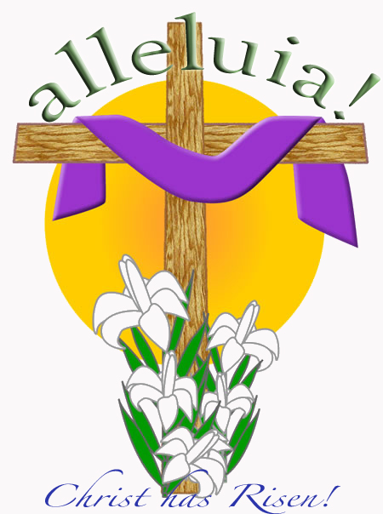
We have purchased some bulk hand sanitizer. Please make arrangements with the parish office if you require some. If possible please bring our own container.

Blessing of the Easter Food
✞ In the name of the Father and the Son and the Holy Spirit.
After forty days of prayer and penance we are ready to rejoice with the entire Church in the resurrection of Jesus our Lord. Let us bow our heads now in prayer, and ask our heavenly Father to bless us. (Moment to pause.)
God of glory, the eyes of all turn to you as we celebrate Christ's victory over sin and death.
Bless us and this food of our first Easter meal.
May we who gather at the Lord's table continue to celebrate the joy of his Resurrection
and be admitted finally to His heavenly banquet.
Grant this through Christ our Lord. R: Amen
Blessed are you, Lord our God,
creator of the universe and our Father,
you have guided us through prayer and fasting,
and now fill our hearts with joy at the Resurrection of Jesus
and our share in his life.
Remember that we are your holy people,
and bless ✞ this food for our rejoicing.
Bless us too, and keep us in your love.
Blessed are you,
Lord our God by all your people for ever and ever.
And let us pray together the words that Jesus taught us. Our Father….

