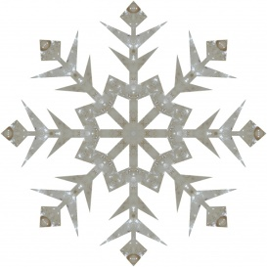

SNOWFLAKE BAZAAR
2017

Paroisse St. Vital Parish’s 5th annual SNOWLAKE BAZAAR is in the planning!
This event promises to be another great fundraiser/community building affair and your Talent and Time can make that happen.
The Bazaar will be held Saturday, November 4th, 2017. Please mark your calendars today and plan to support us in some way.
As noted a Bazaar needs your Talent and Time and products of your gifted hands.
Items such as your handiwork, sewing, arts, crafts, homemade jams & jellies, hand-crafted cards, and baking are all much needed items for the Bazaar.
Once again this year we will be preparing great ‘themed’ gift baskets for purchase and any new items that you wish to donate to complete these baskets are welcomed.
Our ‘gift-in-a-jar’ idea has been such a hit in the last years that this will be a returning project. We ask you to bring in your large Chez Whiz jars so we can have a unique size jar to fill.
Watch for the dates and times for some work bees and our ‘tourtière’ making days. Are you considering a project that could use more hands? Please let us know and work bees can be arranged.
Our previous Bazaars have been tremendously successful due to the participation of great St. Vital parishioners and we can do it again!
Please watch the church bulletins for more information and dates and times for the work bees.
Sign-up sheets will be available this fall, please be generous with your time for this great event!
Any questions or concerns can be directed to the Bazaar Chairman, Carmen at 780-929-8320.

