September 4, 2022
Twenty-Third Sunday In Ordinary Time

Sign-up schedule for proclaimers for the months of August/September weekends is at the back of the church. Please sign up for a mass you will be attending.

Parish office closed on (Labour Day) Monday, September 5, 2022

Fr. Arlan will be away from the parish September 5th – 9th attending the Priest’s Spiritual Retreat and on holidays September 12th – October 1st.

Weekend Mass Times
Saturday 5:00 p.m. (English) Sunday 9:00 a.m. (bilingual) 11:00 a.m. (English)

NO WEEKDAY MASSES
September 6th – September 9th,
September 13th – September 16th
September 20th – September 23rd
September 27th – September 30th

NO ADORATION until October 14th

Check out our website www.saintvitalparish.com and check it regularly for updates.

Mass Intentions
Saturday, September 3rd – SI Madeleine Berube
Sunday, September 4th (9:00 a.m.) SI Xavier Banic & † Dolores Borja Valle (11:00 a.m.)
Saturday, September 10th – †Richard Magnan
Sunday, September 11th (9:00 a.m.) † Richard Magnan & (11:00 a.m.) SI Kate Vukovic
Saturday, September 17th – SI Allsion Naidu & †Ron West
Sunday, September 18th (11:00 a.m.) SI Mary Robinson
Saturday, September 24th SI Kate Vukovic

† = Repose of the Soul SI = Special Intention

Our Lady of the Hill Knights of Columbus will be selling Sobey and No Frills gift cards after all masses on the weekend.

ST. VITAL LADIES’ BANQUET
Monday, September 26th @ 6:00p.m.
Dinner, entertainment, fashion show, door prizes, 50/50 draw & more
Tickets $20.00 and are available at the parish office or call Liz at 780-929-6799.

Scent Free Makes Sense
We would like the parish to be sensitive to folks with allergies and refrain from wearing perfume and aftershave at Mass. Thank you in advance for your consideration.

Knight Rider
The Knights of Columbus are offering to drive, to and from church, any parishioners who wish to attend weekend Masses at St. Vital Church but are unable due to a lack of transportation.
As the Knights are using their private vehicles, they cannot offer assistance for people with mobility issues or those with wheelchairs. Neither can they accommodate car seats for babies or young children. If you think you can take advantage of this free service, contact Joe Lauer at 780-929-6056 to arrange a ride to Mass and back home and we will do our best to accommodate you. Alternate contact: Paul Weisenberger @ 780-929-5150.

Baptism Preparation Course
Are you expecting a child in the near future? Consider taking Baptism Preparation now while you are waiting for the birth of your son or daughter. The classes are for parents and sponsors (godparents). Attending now eliminates the need to find baby-sitters, rearrange feeding schedules etc. plus it adds to the joyful anticipation of your new arrival. Parents wishing to register for the next courses which will be held on Monday, September 19th, 2022
at 7:00 pm please call the parish office.

Are you looking for your faith to come alive or to enkindle a new fire in your spiritual life? Join the Catholic Renewal Services for our Fall Conference The Cross and the Glory, in the hall at St. Theresa’s Church. We will start on Sept 23 at 7:00 pm & 24 from 1:00-4:30 pm ending with a mass and healing service start time 7:00 pm. The mass is open to everyone. Father Emmanuel Ekanem will be our guest speaker and Shophar our music ministry. Registration is $20 and for more information see: www.ccredmonton.info/events. Set this time aside and be prepared to be blessed in your relationship with the Lord.

Steve Bell in Concert — Songwriter, storyteller, and troubadour for our time returns to perform at St. Albert Catholic Parish Church on September 23. Over the course of a 30 year solo career, Steve has been sharing a message of love, hope and faith through songs, stories, and writings. Limited concert tickets now on sale at starofthenorth.ca/steve-bell for $21.00.
The Archdiocese has a number of Papal Visit Keepsake items available for sale via the following link: https://papal-visit-keepsakes.myshopify.com/. With the remaining items being stored locally, they are available for a limited time, and while quantities last. For those who would like to save on the cost of shipping, two options are available:
- Use the discount code PAOpickup to pickup items at the Archdiocesan Pastoral and Administrative Offices
- (or) select the Local Pickup option and for pickup from St. Joseph’s Basilica or Corpus Christi Parish
  - Specify which parish in the Parish Name field at checkout

Catholic summer camp work bee: Can you help? A work bee is being planned for Saturday, September 17 at Our Lady of Victory Camp to prepare the camp for winter. The work bee starts at 8am and will go all day. The work will include general site cleanup, repairs, and preparations for winter. While we can find jobs for almost anyone, we need people who can do some heavy lifting, others with carpentry experience, and some who are willing to do yard clean-up. We will provide refreshments (coffee & water) as well as pizza partway through the day. A reminder to bring your personal protective equipment (gloves, glasses, proper footwear, pants, etc.), which is required for many of the projects. OLVC is one of two camps owned by the Catholic Archdiocese of Edmonton. For more information/register: Deacon Claude Baril camps@caedm.ca or call 403-896-3745.

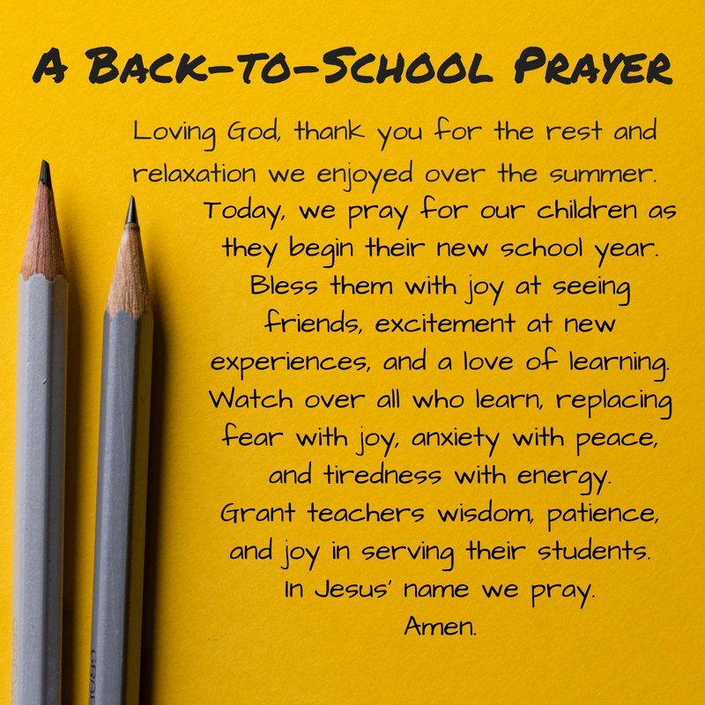
SNOWFLAKE BAZAAR 2022
Saturday, November 5th, 2022

Paroisse St. Vital Parish’s annual SNOWLAKE BAZAAR is in the planning! Plans are underway for the return of our fun-filled event.
You can appreciate that much work and planning needs to be done beforehand so please mark your calendars today and plan to support us in some way. Wonderful plans for a children’s areas is in the works so small homemade items suitable to be bought by young people for parents, siblings, etc. would be welcomed. And we expect the bake sale to be bigger than ever with goodies of all sorts and perhaps some fresh canning as well.
Volunteers will once again be needed to prepare our traditional tourtières as the ‘crew’ have elected to sell our meat pies on a few weekends in November as we did for the last two years during the pandemic, with great success we might add!
We anticipate holding our first formation meeting in early September so please keep informed via the bulletin or the parish website at https://www.saintvitalparish.com/
Do you have something unique and exciting you’d like to prepare for the Bazaar and could use some help, give us a call (780-929-8320) and a work bee or two can be arranged. In the event some work bee days can be fulfilled this summer and you have some time to dedicate to small projects please leave your name and phone number with our Bazaar Chairperson Carmen at 780-929-8320 or by email at carmen.grayson@telus.net.
Any questions or concerns can be directed to the Bazaar Chairman.

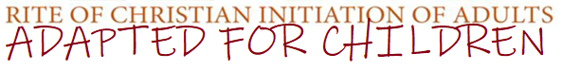
Is your child between the ages of 6 and 15 and not yet baptized or baptized in a different Christian faith? We have a program just for them- RCIC (RCIA adapted for children)

If you are interested in having your older child(ren) baptized, and would like more information, please contact the parish at 780-929-8541.

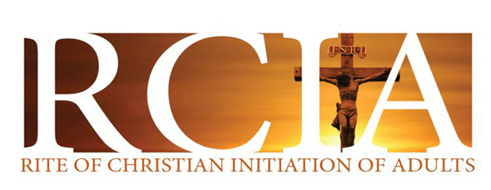
- Are You Interested in Becoming a Catholic?
- Maybe you are baptized but have not been confirmed or have not received your first communion?
- Have you always wanted to learn more about your faith and become part of a community?
The Rite of Christian Initiation of Adults (RCIA) provides an opportunity for adults thinking of joining the Church to learn more about the Catholic faith. Adult Catholics who have not been confirmed or who have not celebrated their first communion are also invited to be part of this process. Through RCIA you journey through an engaging, challenging, enriching experience that is designed to help you come closer to God, and the Church.

Interested persons are asked to contact the parish at 780-929-8541, to schedule an appointment before starting the process.

