October 31, 2021 Thiry-first Sunday in Ordinary Time

Sign-up schedule for proclaimers for the month of November weekends is at the back of the church. Please sign up for a mass you will be attending.

Fr. Arlan will be unavailable during the Mid-Term Assembly of Priests November 9 - 10 inclusive. No morning mass on Tuesday and Wednesday.

Weekday masses
Wednesday, November 10th @ 7:00 p.m. (Memorial Mass for deceased KC members)
Thursday & Friday, November 11th & 12th @ 9:00 a.m.

ADORATION – Friday, November 12th 9:30 a.m. – 4:30 p.m.

Weekend Mass Times
Saturday 5:00 p.m. (English) Sunday 9:00 a.m. (bilingual) 11:00 a.m. (English)
Reconciliation – Saturday 4:15 p.m. – 4:45 p.m.

Mass Intentions
Saturday, November 6th – † Mary Stadlweiser
Sunday, November 7th –(9:00 a.m.) † Erin Strand
Friday, November 12th † Margaret Mary Bowers
Friday, November 19th – SI Paulette Keith
Saturday, November 20th – † Maurice Gariepy
† = Repose of the Soul SI = Special Intention

Parish Office closed on November 11th (Remembrance Day)

From the Office of the Archbishop (dated September 2021)
Response to Requests for Endorsement of Religious Exemption Requests
We cannot endorse requests for a vaccine exemption based on religious grounds, given that the role of the church is to inform through its teaching and ensure respect of the individual conscience not to legitimize its judgments. Moreover, the Bishops of Alberta and the Northwest Territories, in communion with the Holy See, have provided the moral guidance that, in the absence of ethically acceptable alternatives, and in the context of a pandemic that poses a serious threat to public health, it is morally permissible to receive a vaccine approved for use in Canada against COVID.
(cf. Alberta and NWT Bishops Letter to the Faithful on Vaccines – December 2, 2020).

Don’t forget! November 7th, end of Daylight Saving Time: Turn your clocks back 1 hour.

Attention Parishioners
On Sept. 15, the Alberta government declared a local state of public health emergency. COVID cases and hospitalizations are increasing, putting extreme pressure on the health system. The Alberta government has mandated new, temporary measures to curb the spread of COVID. Therefore, the following measures are to be implemented as of this date unless stated otherwise. Here is what’s new. New measures have also been highlighted. What’s new?
• Masks are mandatory
• Capacity is limited to one-third fire code occupancy
• Attendance at baptisms is allowed for up to 50 people or 50 per cent of fire code occupancy, whichever is less.
• No social gatherings are permitted in parish halls and facilities.
• Each parish will implement previous protocols to determine attendance (At the present time St. Vital will use first come, first served)
• The dispensation from the obligation to attend Sunday Mass continues for dioceses in the Province of Alberta.

“CALLED TO PROTECT”:
The next “Safe Environment and Abuse Prevention” training session, Called to Protect by zoom is scheduled for Monday, November 15. The 2.5 hours session will start at 7:00-9:30pm. This is a requirement for all volunteers and employees in the Archdiocese 18 years and older.
For registration or more information, please call Jeanne at 780-994-1663 prior to Friday, November 12. You will need to have access to a computer for login and training.

Baptism Preparation Course
This program is designed to assist parents in their preparation for the baptism of their children up to the age of 7. Parents and godparents are encouraged to understand how important it is for them to share their faith life with their children as this will be the basis for their children’s faith journey.
Call the parish office to register for a course to be held on Monday, November 8th.

Living with Christ Missals available at the back of the church ($7.00)

SNOWFLAKE BAZAAR 2021
Tourtière Sales 2021
Paroisse St. Vital Parish’s 10th annual SNOWLAKE BAZAAR is once again downsized this year to adhere to the provincial regulations. You can appreciate that much work has to be done for the Saturday sales so please mark your calendars today and plan to support us in any way that you are able.

PLEASE leave your name and number with our Bazaar Chairperson Carmen at her home at 780-929-8320, by call or text to cell 780-908-5328 or by email at carmen.grayson@telus.net.

Any questions or concerns can be directed to the Bazaar Chairman.
Schedule is as follows:
Meat preparation starting at 9am at the Seniors Centre on 50th Avenue.
8 Roaster ovens will be required.
Pie making commences at 1pm each afternoon at the same location.
Various tasks are involved.
Tuesdays on November 9 – November 16 – November 23
Wednesdays on November 10 – November 17 – November 24

Sale of Tourtiéres – every Saturday in November starting at 9 AM till supplies last

VOLUNTEER Helper sign-up sheets are on the table at the entrance of the church.
Thank you in advance for your consideration of this fundraising project.

Sale of Tourtiéres – every Saturday in November starting at 9 AM till supplies last

VOLUNTEER Helper sign-up sheets are on the table at the entrance of the church.
Thank you in advance for your consideration of this fundraising project.

Pro-Life Petition
Our Lady of the Hill Council Knights of Columbus asks for your support with a petition drive sponsored by Prolife Alberta. The details of this petition are explained on the forms which aron a table at the back of the church. Once collected, they will be presented at the Alberta Legislative Assembly. Please consider supporting this worthwhile Pro-life endeavor

Stewardship Corner 31st Sunday in Ordinary Time Weekend of October 30/31 2021
Stewardship Corner 31st Sunday in Ordinary Time Weekend of October 30/31, 2021 In today’sGospel Jesus said: “You shall love your neighbor as yourself.” It was not meant to be

Infant Memorial Mass
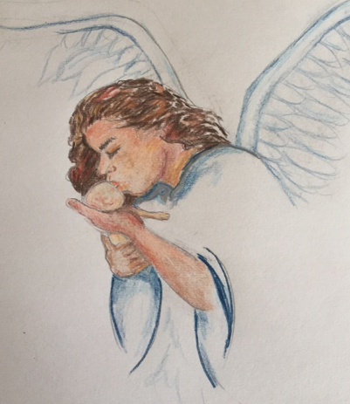
The Infant Memorial Mass will be held Nov. 23 at 6:15 p.m. at Our Lady of Perpetual Help Church in Sherwood Park.
A service will honour and remember children who have died due to miscarriage, abortion, stillbirth, infant or childhood death.
We welcome and invite all those who have suffered the loss of a child to join us.
You are invited to write your child’s name on a card provided and place it on the Remembrance Tree in the church foyer, or email info@olph.ca and they will write the name for you.

Books of Remembrance
The Church devotes the month of November to prayer for the Holy Souls, those who have died in grace yet failed to make satisfaction for all their sins. Praying for the Holy Souls is a Christian obligation. Please write the names of your family and friends in this book, praying for them as you inscribe their names. If you are not attending mass at the present time and would names written in the book, please e-mail St.vitalchurch@shaw.ca and we will include those names. We will pray for all those named throughout the month. If you wish to offer a Mass for family or friends who have died, visit the parish office.

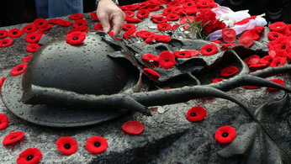
A Prayer of Remembrance
Ever-living God,
we remember those whom
you have gathered from the storm of war
into the peace of your presence;
may that same peace calm our fears,
bring justice to all peoples
and establish harmony among the nations,
through Jesus Christ our Lord.
Amen.
Hear the Word of God and Do it
Living in the Word— It is important to create opportunities for fellow disciples to gather and reflect deeply upon the Word of God. In this way we not only support one another as we grow in our relationship with Jesus, but also encourage one another to embrace the common mission that is ours in virtue of our Baptism into his Church. What . . . opportunities might we fashion? I ask our parishes, ecclesial movements, and Catholic institutions to consider this question carefully and offer ways in which God's sacred Word can be commonly heard and embraced. (Archbishop Smith, Pastoral Letter, September 14, 2017) caedm.ca/letter

Why doesn’t someone invent a clear toaster so you can see how toasted your toast is while it’s toasting?

So you are staying at home, keeping a safe distance from others, cleaning yourself often, and napping whenever you can? Congratulations, you’ve become a house cat!

My boss told me to have a good day. I went home.

Currently, my ears are carrying my headphones, sunglasses and face mask. Ears are the new purse.

Why is it that our hands have fingertips, but our toes don’t have toetips, yet we can tiptoe?

