MASS INTENTIONS
Sunday, June 2nd (11:00 a.m.) ✞ Rod Rance & Theresa LeClair)

“Jackets for Jesus & Coats for Christ”
Catholic Social Services needs our help!
Every year, our friends and partners at Catholic Social Services distribute over 1000 coats to homeless or vulnerably housed men, women and children as part of their Uplift Day in September. In preparation, CSS is seeking gently-used jackets and coats of all sizes. A box will be placed in the church entrance until June 22/23
Thank you for your generosity. Together, we can help keep some of our most vulnerable sisters and brothers warm.
Sincerely,
Gerald Sseguya

CEMETERY
Flowers are only allowed to be securely placed on the cement runners and not on the grass. Any flowers on the grass will be removed so the cemetery can be maintained.
The St Vital CWL has planned a lunch for you and your family on Sunday June 9 following the 11 am mass. This Spring Luncheon is the CWL’s main fundraiser. Not only will you be able to have a scrumptious lunch, you will also be able to buy baked goods, Mundare sausage 10.00/ring ( including gluten free) AND shop at the White Elephant Sale. How exciting! Please support the CWL and the good work they do in the parish and community.Note Mundare sausage will also be on sale after all masses Saturday and Sunday June 15 and 16
PARISHIONERS! Dress in the “spirit” of the occasion on Pentecost, June 9, 2019. This is an invitation to dress in your reds, yellows and oranges. Help enhance a truly wonderful celebration

The Pope’s Monthly Intention
That priests, through the modesty and humility of their lives, commit themselves actively to a solidarity with those who are most poor

It is the policy of the Archdiocese of Edmonton that if you are going to share your time and talent in any parish ministry at Edmonton Archdiocesan Parishes you are required to attend a Called to Protect Session. If you have not yet done so please register for one of the upcoming sessions;
Wednesday, June 12th at 7:00 pm. Please contact the OLPH Parish Office at 780-467-5470 to register.

K of C Food Bank Drive – 169 pounds of food was delivered to the Leduc Food Bank .

Planning a Vacation? Don’t Forget to Plan Parish Giving
Our ministries and parish initiatives continue throughout the summer.
If you will be away from St. Vital this summer, please make sure you find replacements if you are scheduled to serve while you are out of town. We can also set up preauthorized debits from your account or hold post dated cheques at the office. Thank you for your ministry and your generous support.

53 Annual World Communications Day

This Sunday, the Church marks the 53rd Annual World Communications Day, a day when we are invited to reflect on all forms of media and how they influence our lives. In his message for this day, Pope Francis addresses the danger of mistaking online communications with truly human relationships, and suggests we all have a part to play both as critical consumers of media and as messengers of hope and goodness in our own online activities. "While governments seek legal ways to regulate the web and to protect the original vision of a free, open and secure network," he writes, "we all have the possibility and the responsibility to promote its positive use." "The Church herself is a network woven together by Eucharistic communion, where unity is based not on “likes,” but on the truth, on the “Amen”, by which each one clings to the Body of Christ, and welcomes others." Taken from Quid Novum, May 28, 2019

Living in the Word - What message do I communicate to others by my way of living, patterns of thought and speech, or modes of behaviour? Out of concern for reputation or fear of rebuke, do I stay silent when circumstances require that I speak the truth? The Holy Spirit has been given that we might be witnesses. Let us call upon him to provide us with the ability to do so and thus put into practice the Word of God. (Archbishop Smith, Pastoral Letter, September 14, 2017)

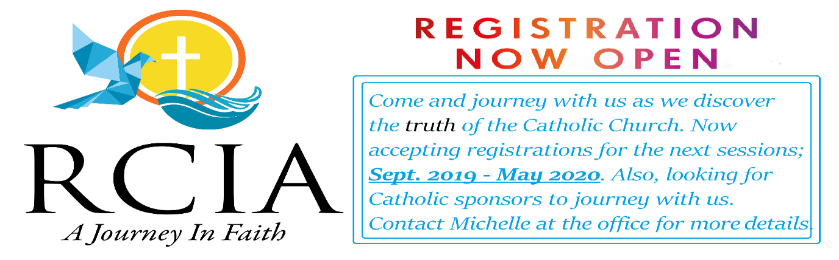

Shalom Retreat Edmonton | June 21-23, 2019 Shalom Media Canada invites you to a three-day inner healing retreat that will shine the light of Christ into your heart and lead you to forgiveness, freedom and healing. This retreat will nourish you to look up to Him with renewed faith and a refreshed spirit. Venue: St. Theresa's Catholic Parish, MacNeil Hall, 7508 29 Ave., Edmonton, AB T6K 3Y8 Dates: Friday June 21, 2019 8:00 AM - 7:00 PM | Saturday June 22, 2019 8:30 AM - 7:00 PM | Sunday June 23, 2018 8:30 AM - 4:00 PM. Registration Fee: $80 Adults | $50 Youth (Lunch and Dinner will be provided) Limited seats available. Register today to confirm your participation!
Register online at payments.shalommedia.org/2019/retreat/edmonton
Contact: Rachel 780-906-8347 | Varkey 780-937-6411

Catholic Family Conference
Catholic Family Ministries invites you to join them for this year’s Family Life Conference on the Canada Day long weekend (June 28-July 1) at Lac Ste. Anne. Experience a host of inspiring speakers, including Tim Gray, President of the Augustine Institute; Sister Helena Burns of the Daughters of Saint Paul, and Ryan Topping, Vice-President and Academic Dean of Newman Theological College. For more information and to register, please visit: catholicfamilyministries.com . Online registration is now open!

First Communion
June 1, 2019
Tayen Antony Addison Kennedy
Paul Badger Greyson Kennedy
Jillian Bagan Avery Korethoski
Austin Boisvert Alyson Lessard
Landon Bujold Madison Murphy
Chincin Divinagracia Joshua Liam Nunes
Benhard Divinagracia Cloe Pedersen
Chalcy Divinagracia Henry Pugh
Quinn Farrell Matthew Ridgway
Kya Fedoruk Joshua Riopel
Emmanuel Fitzgerald Isabella Sergi
Brooklyn Glenn Hannah Wong
Sullivan Harris Gracie Wozny
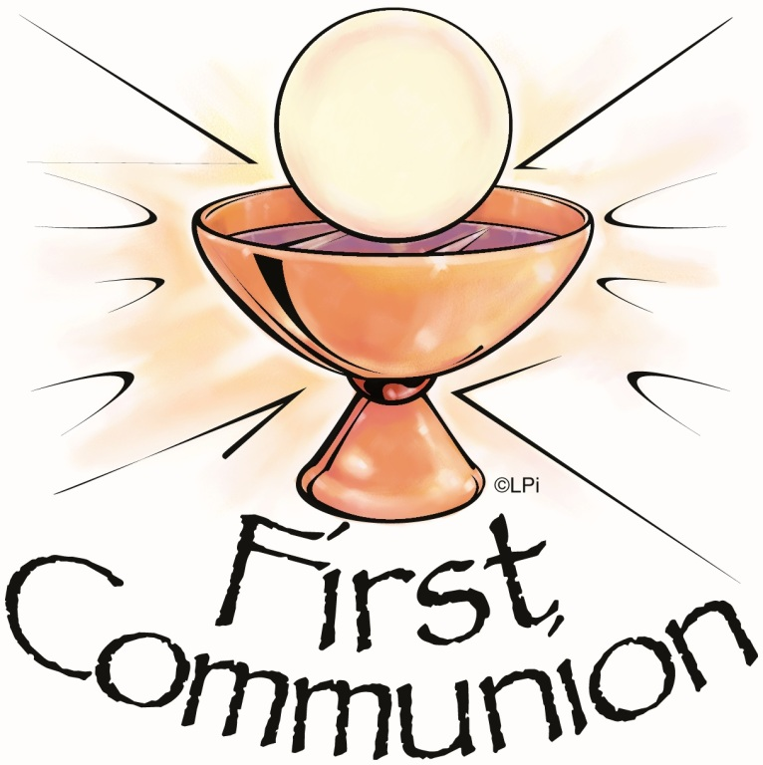

Please keep these young parishioners and their families in your prayers.

