Mass Intentions
Saturday, December 15th Sharon Langlois
Sunday, December 16th (11:00 a.m.) Veronica Short
Tuesday, December 17th ✞ Christine Laurence
Friday, December 20th ✞ Eveline Labonte

Concerts at St. Vital’s
Thursday, December 19th (7:00p.m.) Swiss Men’s Choir
Friday, December 20th (7:00 p.m.) Beaumont Society of the Arts Concert

A second collection will be taken at all Christmas Eve Masses and Christmas Day for Pay Down the Debt.

Blank schedules for Christmas and New Year's Eve Masses are at the back of the church. Please fill in your name for the mass you will be attending.

JOIN US FOR EVENING VESPERS
When: Friday, December 13
Wednesday, December 18
Time: 7:00 – 7:45 p.m.
Place: St. Vital Church
Fellowship & refreshments in parish hall following each session

2020 Donation Envelopes
Sunday Offering Envelopes for the new year (displayed alphabetically) are now available for pick up by parishioners. Weekly contribution envelopes are only good for the year they are printed as numbers may change. Therefore, please DO NOT USE YOUR 2019 ENVELOPES FOR CONTRIBUTIONS TO BE MADE IN 2020. If you currently do not use envelopes and wish to do so, please contact the parish office by phone or email. Parishioners also have the option of donating thru automatic bank withdrawal (once a month) (Forms are at the back of the church)

'Hear the Word of God and Do It
Living in the Word ̶ ̶ Even if we take as little as ten minutes each day to read a few lines of the Bible, or one of the readings assigned for daily mass, this encounter with Christ will change our lives. (Archbishop Smith, Pastoral Letter, September 14, 2017)

Baby Bottles for Babies….. A CWL 40 Days for Life project

The St Vital CWL will be launching a project to support the Choice of Life. In doing so, we ask for your help in recycling and donating used baby bottles. NOTE: these bottles will be used to collect your offerings made over the Lenten season. Money raised will be used to support and assist women who have chosen life over abortion. Please drop the bottles off in baskets located at the entrance of the church or at the Parish office before December 15. Thank you.

CHRISTMAS AND NEW YEARS MASS TIMES
Christmas Eve Tuesday, December 24
3:30 pm Christmas Nativity Pageant
Christmas Eve Masses
4:00 pm 6:30 pm 9:00 pm & Midnight Mass (12am)
Christmas Day Wednesday, December 25
10:00am Mass
Feast of the Holy Family Sunday, December 29 –
9:00 am & 11:00 am
New Year’s Eve (Feast of the Holy Mother of God)
Tuesday, December 31 - 5:00pm Mass
New Year’s Day (Feast of the Holy Mother of God)
Wednesday, January 1, 2020 - 10:00 am Mass

24 Hour Adoration – January 3rd Sign up sheet in the Adoration binder.
All time slots must be filled to avoid cancellation.

Paperless Bulletin
Are you looking for ways to increase your care for the environment? Reducing the amount of paper that is used to produce our bulletin is one way that you can contribute. To receive your paperless bulletin email St.vitalchurch@shaw.ca.

The Knight’s of Columbus will be having their Pancake Breakfast on Sunday, Dec. 15
after both masses. For this month we will be serving baked beans on top of our pancake, ham, scrambled eggs, strawberries, coffee, juice and tea. Come join us at the church basement.

Carmelite Monastery Craft Sale
December 15th after 9 & 11 a.m. mass.
Crafts and handmade cards will be on display downstairs for purchase.
Monetary donations also accepted.
Please help support the Carmelites

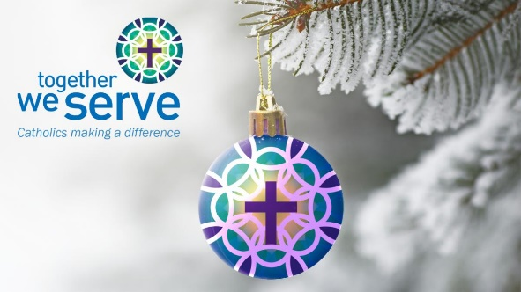  Pope Francis tells us, “Being Christian is living and witnessing to faith in prayer, in works of charity, in promoting justice, in doing good.” The Together We Serve appeal enables us to enter into the mission of Jesus together, and to serve our brothers and sisters in Christ in a way we could not possibly do individually. Your gifts through Together We Serve enable us to make a greater difference as a family than we ever could as individuals. | Your support enables partner organizations to help:  - Women and children escaping domestic violence  - People recover after a devastating earthquake  - The Holy Father respond to global emergencies  - Train & educate future priests  - Educate pastoral assistants and teachers  - Spread the light of Christ far and wide  As we approach the end of the year, please consider putting your faith into action, by making a gift to Together We Serve. Donations can be made through the parish or online at caedm.ca/TogetherWeServe.

