“Pastor’s Christmas Message”
My dear Brothers and Sisters in Christ,
We have completed our Advent journey and now we celebrate another Christmas together. We celebrate as family, one in the spirit of Christmas. Celebrating that awesome mystery of Christs’ birth.

The Christmas story is one of the most popular stories in all of history. Jesus breaks into our fragile world to be one with us, and to reveal his love for us. What a compassionate and loving God we have. He loved us so much that he sent his Son to show us the way to heaven. He is born so that he can die for us and lead to salvation. He loved us so much that he sent his Son to show us the way to heaven.

Taking on flesh and becoming one like us is what Christmas is all about. Coming to the realization that Christ came to us for a specific reason— “God so loved the world that He gave His only begotten Son so that whosoever shall believe in him shall have eternal life”. Christ’s message is a message of hope, faith, love and peace on earth; moreover, a message packed with mysticism, wonder, excitement and joy.

So, as we celebrate the miracle of Christmas let us remember that God made his dwelling place among men, women, and children, and called them to be holy.

Let us celebrate the mystery of the incarnation of Christ and be filled with everlasting the joy. Without Christ, the world was a joyless place; and any place where he remains unknown and unaccepted is a joyless place. Everything has changed since Christ’s birth, yet everything remains to be changed, especially when people come to receive Christ as their saviour.

May this time of Christmas be a special time with family and friends, and to acknowledge the ongoing presence of Jesus Christ in our lives. Thank you, Jesus, for breaking into the world you created and showing us the way home.

Wishing you a “Very Merry Christmas” and a “Happy New Year.”

Merry Christmas & Happy New Year,
Love & Prayers,
Fr. Arlan Parenteau

.

Merry
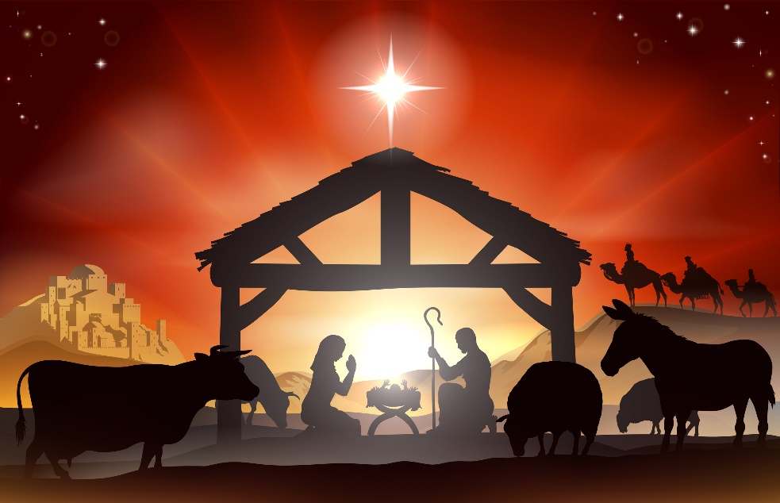
Christmas

& happy New Year!

Paroisse St. Vital Parish
