MC900022214[1]

**A huge THANK YOU to ALL who participated**

**and supported the parish’s**

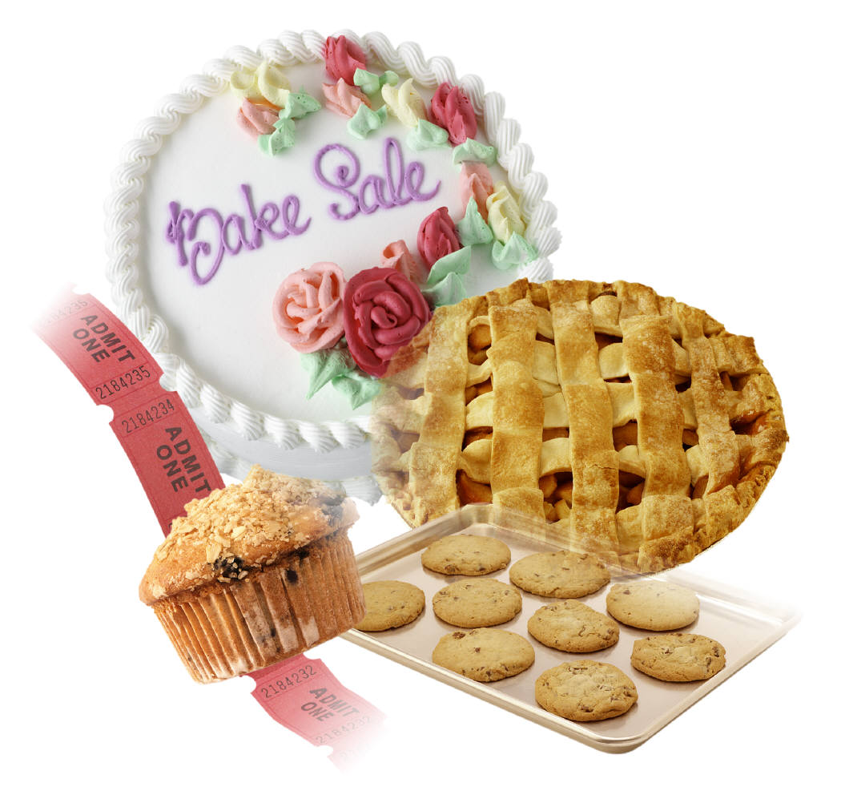

MC900021628[1]

**2018 SNOWFLAKE BAZAAR**

**&**

**BAKE SALE.**

**The total profits from the event were $8979.76.**

**This year’s huge BAKE SALE brought in $2,499.50; *WONDERFUL!***

**We served lunch to 48 individuals, our infamous tourtières all sold early in the morning.**

**We are grateful for donations received which allowed us to purchase a freezer to store the meat pies.**

**EVERYONE’s generosity of time, energy and all the great donations for the Bazaar & Bake Sale were truly what made it the success it was!**



**Again a most sincere THANK YOU to ALL**

**who warmly worked together from the launch of this Bazaar undertaking right to the clean-up.**

MC900022214[1]